**DAY 6 TASK**

**1.Creating author Component for fetching card details**

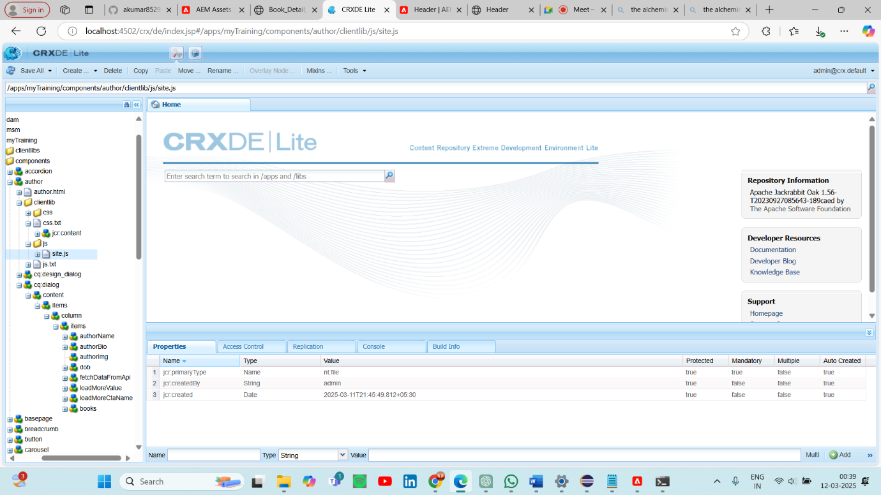

**2.The HTML file renders the book cards**

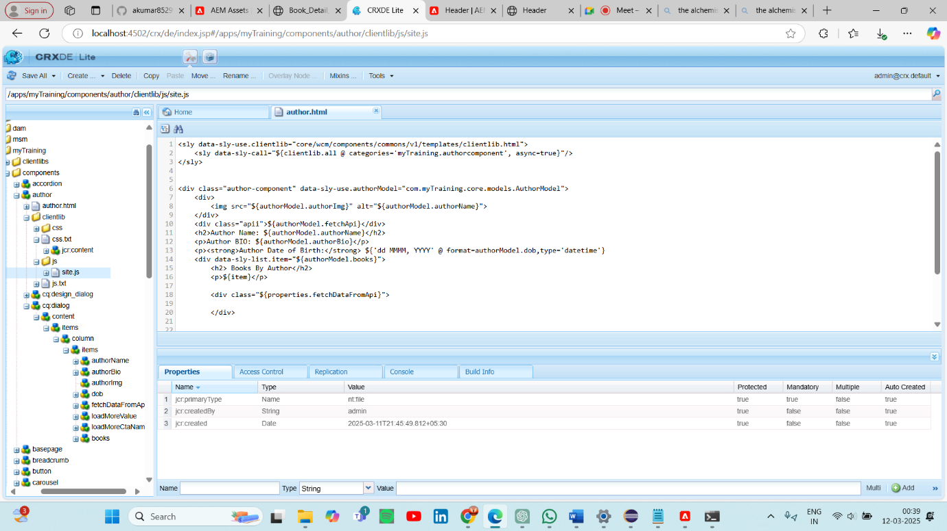

**3.Adding site.js in clientlibs folder for fetching data using API url**

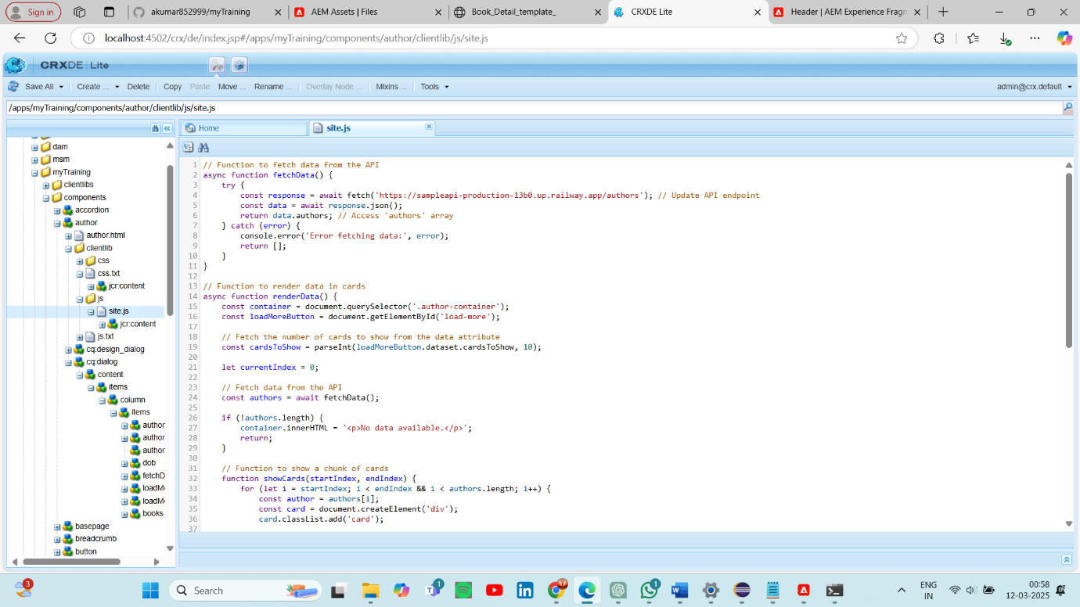

**4.author component details**

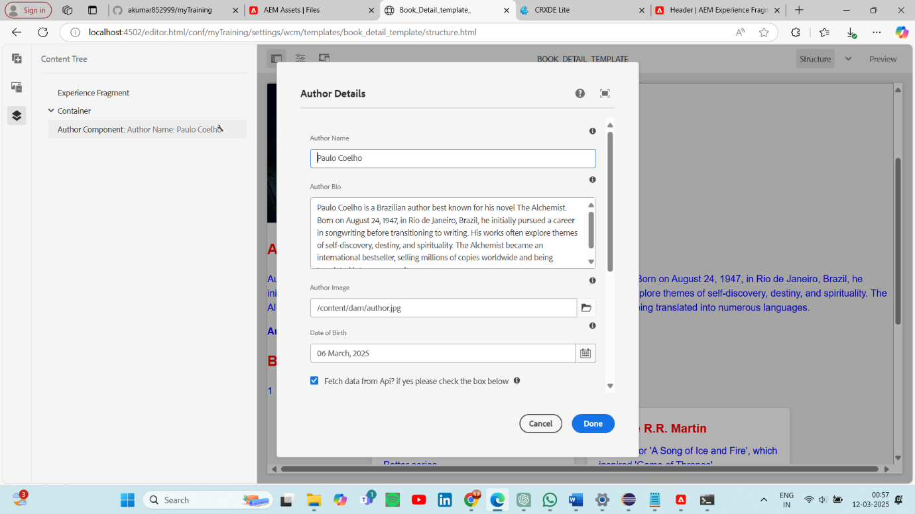

**5.Output**

